Data Mining Project Report:
Music "Vibe" Segmentation Using Clustering on Spotify Dataset
Author : Justin Matthew T
Student ID : A11.2023.14877

1. Main Objective of the Analysis
The main objective of this analysis is to perform segmentation (clustering) on Spotify’s song catalog based on their intrinsic audio characteristics. This analysis combines two Unsupervised Learning techniques: Clustering as the primary goal and Dimension Reduction as the supporting method.
Specifically, Dimension Reduction (PCA) is first applied to simplify 7 complex audio features into 2 main components. Then, Clustering (K-Means) is applied to these simplified components to discover meaningful and visually interpretable “vibe” segments of songs.
The business benefits of this analysis include improving user experience and content strategy through:
- Better Music Recommendations: By understanding the “vibe” of a song (e.g., “High Energy” vs. “Chill Acoustic”), we can recommend musically similar tracks, even across different artists or genres.
- Automated Playlist Generation: Enables smarter and more cohesive playlist creation (e.g., “Focus Playlist” or “Party Playlist”) automatically.
- Content Insights: Provides deeper understanding of the “audio recipe” of various music segments on the platform.

2. Data Description and Initial Exploration
Dataset Download: https://www.kaggle.com/datasets/zaheenhamidani/ultimate-spotify-tracks-db
Colab Link: https://colab.research.google.com/drive/1CPE5_yT7bLUTB5aeUlRQv9JjEWo1tO44#scrollTo=_uRg5IyJRrH8
The chosen dataset is “Spotify Tracks DB” (SpotifyFeatures.csv), a comprehensive database containing metadata and audio features extracted by Spotify for thousands of songs.
• Key Attributes:
This analysis focuses on 7 primary numerical audio features that define a song’s “feel”:
- acousticness: Confidence measure (0.0–1.0) indicating whether a track is acoustic.
- danceability: Measure (0.0–1.0) indicating how suitable a track is for dancing, based on tempo, rhythm stability, and beat strength.
- energy: Measure (0.0–1.0) representing intensity and activity. Energetic tracks feel fast, loud, and noisy.
- instrumentalness: Measure (0.0–1.0) predicting whether a track lacks vocals.
- liveness: Measure (0.0–1.0) detecting the presence of an audience (indicating a live recording).
- loudness: Overall sound level in decibels (dB), typically ranging from -60 to 0 dB.
- speechiness: Measure (0.0–1.0) detecting the presence of spoken words. High values indicate non-musical content (e.g., podcasts, audiobooks).
• Objective:
Use these 7 audio features to cluster songs into sonically homogeneous segments, without using genre or artist information.
• Data Size:
The full dataset contains hundreds of thousands of entries. For efficiency and computational performance, a random sample of 20,000 tracks was used for this project (original dataset size: 232,725 tracks).

3. Data Preparation (Data Cleaning & Feature Engineering)
The following data preparation steps were performed before modeling:
- Cleaning: Duplicate entries based on track_id and rows with missing (NaN) audio feature values were removed.
- Feature Selection: Only the 7 relevant audio features (listed above) were selected as model inputs.
- Standardization (Scaling):
This crucial step standardized all 7 audio features using StandardScaler (from Scikit-learn), transforming them to have mean = 0 and standard deviation = 1.
This ensures that features like loudness (range -60 to 0) do not dominate features like danceability (range 0 to 1).

4. Model Training Summary
To achieve optimal and visualizable clustering results, a two-step approach was used:
- Dimension Reduction (PCA):
The 7 standardized features were reduced into 2 Principal Components (PCA) for 2D visualization.
These two components captured 66.30% of the total data variance.
- Clustering (K-Means):
The K-Means model was applied on the 2 PCA components.

Three model variations were trained to determine the optimal number of clusters (K), supported by two evaluation methods:
- Experiment 1 – Elbow Method:
The Elbow Plot showed that WCSS (inertia) started flattening significantly after K=4 or K=5, indicating 4, 5, or 6 as potential cluster counts.
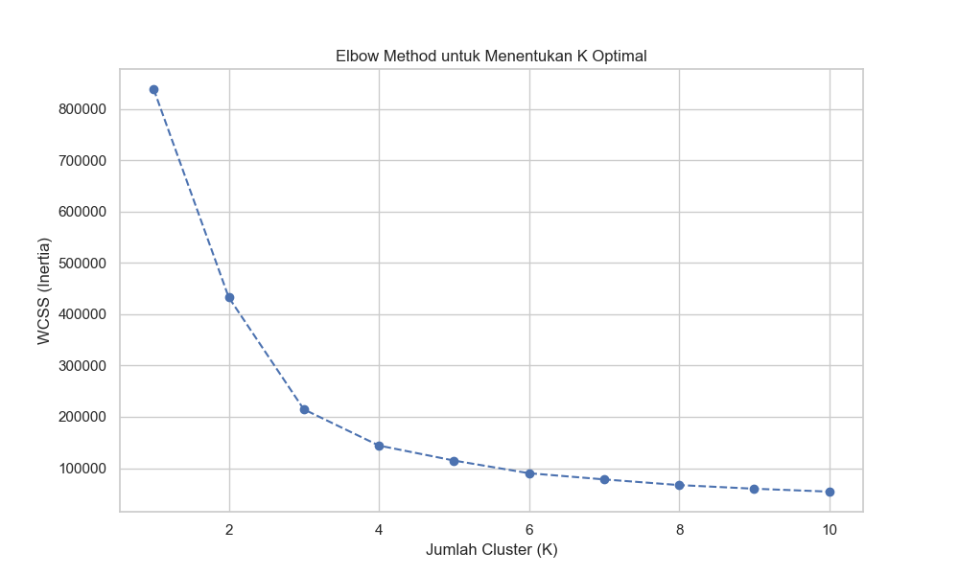
2. Experiments 2, 3, 4 – Silhouette Score Comparison:
K-Means models with K=4, K=5, and K=6 were compared using their Silhouette Scores (higher is better).
Model (Variation) | Silhouette Score
K-Means with K=4 | 0.4798 (BEST)
K-Means with K=5 | 0.4507
K-Means with K=6 | 0.4287

5. Final Model Recommendation
Based on the comparison above, K-Means with K=4 is recommended as the final model.
Reason:
This model achieved the highest Silhouette Score (0.4798), indicating the most statistically optimal cluster separation. Additionally, these 4 clusters yielded four distinct, meaningful, and actionable “song personas,” described below.

6. Key Findings and Insights
The analysis successfully identified 4 distinct "vibe" segments from 20,000 tracks.
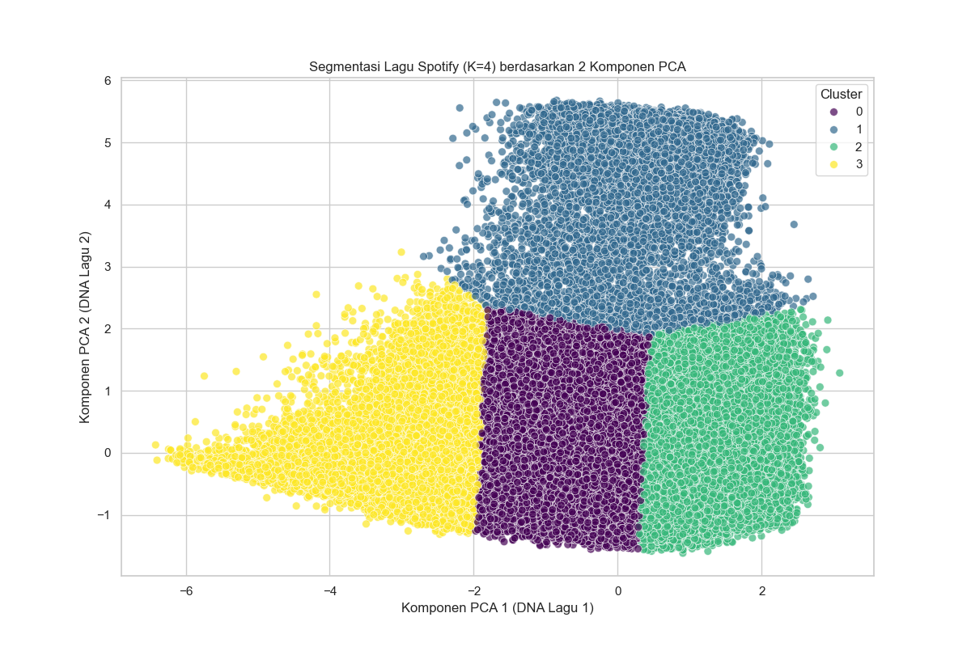
cluster_label | acousticness | danceability | energy | instrumentalness | liveness | loudness | speechiness
0 | 0.124195531 | 0.623630605 | 0.73836009 | 0.038587227 | 0.200991002 | -6.024179298 | 0.103229606
1 | 0.539906433 | 0.542638344 | 0.427977089 | 0.180438039 | 0.164529901 | -10.70484926 | 0.066576771
2 | 0.895569432 | 0.306712781 | 0.143565869 | 0.580703384 | 0.155902428 | -20.73804106 | 0.050170689
3 | 0.728573632 | 0.551012948 | 0.666997211 | 0.003048721 | 0.741231574 | -11.43844522 | 0.782036653
• Cluster 0: "High Energy / Mainstream Party Tracks"
- Profile: Very high energy (0.74) and loudness (-6.02), with high danceability (0.62). Very low acousticness (0.12).
- Insight: Represents commercial pop, EDM, and dance tracks that dominate party playlists.

• Cluster 1: "Chill Acoustic / Relaxed Vibes"
- Profile: Moderately high acousticness (0.54) with low-to-medium energy (0.43) and loudness (-10.70).
- Insight: Represents easy-listening, pop-acoustic, and folk music. Ideal for chill playlists.
• Cluster 2: "Instrumental Calm / Classical & Ambient"
- Profile: Extremely high acousticness (0.90) and instrumentalness (0.58), with very low energy (0.14) and loudness (-20.74).
- Insight: Represents calm, quiet instrumental music — perfect for focus, study, or sleep playlists.
• Cluster 3: "Spoken Word / Live Recordings"
- Profile: Exceptionally high speechiness (0.78) and liveness (0.74), much higher than other clusters.
- Insight: A fascinating finding — the model isolated non-musical content such as podcasts, stand-up comedy, or live concert recordings into its own segment.

7. Limitations and Future Work
While the analysis was successful, several limitations and improvement opportunities were identified:
• Model Limitations:
- PCA Information Loss:
Using PCA for visualization (reducing 7 features to 2) causes information loss (~33.70% variance).
Clusters that appear overlapping in 2D may actually be well-separated in the full 7-dimensional space.
- “Spoken Word” Cluster Diversity:
Cluster 3 may be too broad, mixing podcasts, comedy, and live concert recordings.
• Recommended Next Steps:
- Genre Analysis:
Conduct deeper analysis within Clusters 0, 1, and 2 to see genre distribution. For example, is the “High Energy” segment dominated by Pop or Hip-Hop?
- Sub-Clustering:
Take Cluster 3 (“Spoken Word”) and perform sub-clustering on its subset to further separate podcasts from live concerts.
- Full-Dimension Clustering:
Apply clustering on all 7 original audio features (without PCA) and compare results, even if not directly visualizable.

